The statistics of the World Championship in fire and rescue (fire-applied) sport
among men sports teams
№  п/п | The name of the Championship | Venue | The year | Winners and prize-winners of the Championship
1. | I World Championship | Moscow  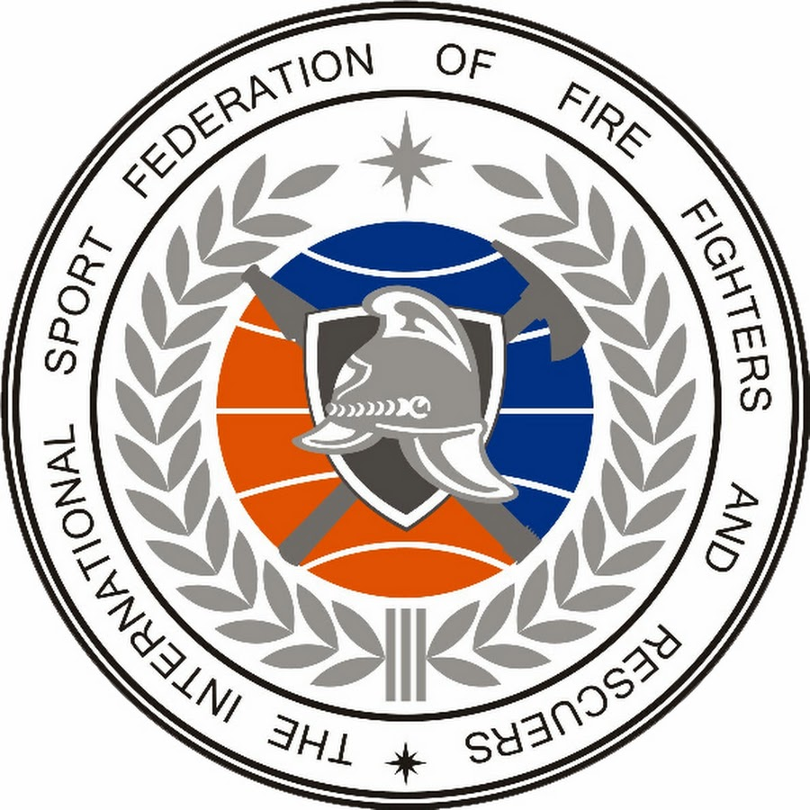  (Russian Federation) |  | I - The Republic of Belarus  II - Russian Federation  III - Ukraine
2. | I World Championship | Saint-Petersburg  (Russian Federation) | 2003 | I - Russian Federation  II - The Republic of Belarus  III -Ukraine
3. | II World Championship | Minsk  (The Republic Of Belarus) | 2004 | I - The Republic of Belarus  II - Ukraine  III - Czech Republic
4. | II European  Championship | Ostrava  (Czech Republic) | 2005 | I - The Republic of Belarus  II - Czech Republic  III - Ukraine
5. | III World Championship | Teheran  (The Islamic Republic of Iran) | 2006 | I - Russian Federation  II - Ukraine  III -The Republic of Belarus
6. | III European  Championship | Ostrava  (Czech Republic) | 2007 | I - Czech Republic  II - Russian Federation  III - The Republic of Belarus
7. | IV World Championship | Sofia  (Republic of Bulgaria) | 2008 | I - The Republic of Belarus  II - Russian Federation  III – Czech Republic
8. | V World Championship | Ufa  (Russian Federation) | 2009 | I - Russian Federation  II - Czech Republic  III - Ukraine
9. | VI World Championship | Donetsk  (Ukraine) | 2010 | I - Ukraine  II - Czech Republic  III - The Republic of Belarus
10. | VII World Championship | Cottbus  (The Federal Republic of Germany) | 2011 | I - Russian Federation  II - The Republic of Belarus  III - Republic of Kazakhstan
11. | VIII World Championship | Antalya  (Republic of Turkey) | 2012 | I - Russian Federation  II - Czech Republic  III - Ukraine
12. | IX World Championship | Jinju  (Republic of Korea) | 2013 | I - Ukraine  II - The Republic of Belarus  III – Czech Republic
13. | X World Championship | Almaty  (Republic of Kazakhstan) | 2014 | I - The Republic of Belarus  II - Czech Republic  III – Russian Federation
14. | XI World Championship | Saint-Petersburg  (Russian Federation) | 2015 | I - Russian Federation  II - The Republic of Belarus  III – Czech Republic
15. | XII World Championship | Ostrava  (Czech Republic) | 2016 | I -The Republic of Belarus  II - Ukraine  III - Czech Republic
16. | XIII World Championship | Izmir  (Republic of Turkey) | 2017 | I – The Republic of Belarus  II – Russian Federation  III - Ukraine
17. | XIV World Championship | Banskа Bystrica  (Slovak Republic) | 2018 | I – Czech Republic  II – Ukraine  III - The Republic of Belarus
18. | XV World Championship | Saratov  (Russian Federation) | 2019 | I – Russian Federation  II – Republic of Kazakhstan  III - Czech Republic

The statistics of the World Championship in fire and rescue (fire-applied) sport
among women sports teams
№  п/п | The name of the Championship | Venue | The year | Winners and prize-winners of the Championship
1. | I World Championship | Almaty  (Republic of Kazakhstan) | 2014 | I - Russian Federation  II - Republic of Kazakhstan  III - The Federal Republic of Germany
2. | II World Championship | Saint-Petersburg  (Russian Federation) | 2015 | I - Russian Federation  II - Czech Republic  III - The Republic of Belarus
3. | III World Championship | Ostrava  (Czech Republic) | 2016 | I - Russian Federation  II - The Republic of Belarus  III – Czech Republic
4. | IV World Championship | Izmir  (Republic of Turkey) | 2017 | I - Czech Republic  II – Russian Federation  III – Republic of Kazakhstan
5. | V World Championship | Banskа Bystrica  (Slovak Republic) | 2018 | I - Russian Federation  II - Czech Republic  III – The Republic of Belarus
6. | VI World Championship | Saratov  (Russian Federation) | 2019 | I - Russian Federation  II - Czech Republic  III – The Republic of Belarus

The statistics of the World Championship in fire and rescue (fire-applied) sport
among young men and juniors sports teams
№  п/п | The name of the Championship | Venue | Theyear | Winners and prize-winners of the Championship
1. | I World Championship | Kazan  (Russian Federation) |  | I – Russian Federation  II – The Republic of Belarus  III – Ukraine
2. | II World Championship | Saint-Petersburg  (Russian Federation) | 2011 | I – Ukraine  II – Russian Federation  III – The Republic of Belarus
3. | III World Championship | Valmiera  (Republic of Latvia) | 2012 | I – The Republic of Belarus  II – Russian Federation  III – Ukraine
4. | IV World Championship | Podolsk  (Russian Federation) | 2013 | I – Czech Republic  II – Russian Federation  III – Ukraine
5. | V World Championship | Svitavy  (Czech Republic) | 2014 | I – The Republic of Belarus  II – Russian Federation  III – Ukraine
6. | VI World Championship | Grodno  (The Republic of Belarus) | 2015 | I – Czech Republic  II – Russian Federation  III – Ukraine
7. | VII World Championship | Ostrava  (Czech Republic) | 2016 | I – The Republic of Belarus  II – Czech Republic  III – Russian Federation
8. | VIII World Championship | Varna  (Republic of Bulgaria) | 2018 | I – The Republic of Belarus  II – Russian Federation  III – Czech Republic
9. | IX World Championship | Saratov  (Russian Federation) | 2019 | I - Russian Federation  II - The Republic of Belarus  III – Czech Republic

The statistics of the World Championship in fire and rescue (fire-applied) sport
among girls and juniors sports teams
№  п/п | The name of the Championship | Venue | The year | Winners and prize-winners of the Championship
1. | I World Championship | Svitavy  (Czech Republic) | 2014 | I - The Republic of Belarus  II - Czech Republic  III - Russian Federation
2. | II World Championship | Grodno  (The Republic of Belarus) | 2015 | I - The Republic of Belarus  II - Russian Federation  III – Republic of Poland
3. | III World Championship | Ostrava  (Czech Republic) | 2016 | I - Russian Federation  II - Republic of Belarus  III - Czech Republic
4. | IV World Championship | Varna  (Republic of Bulgaria) | 2018 | I - The Republic of Belarus  II - Russian Federation  III - Czech Republic
5. | V World Championship | Saratov  (Russian Federation) | 2019 | I - Russian Federation  II - Czech Republic  III - The Republic of Belarus

The statistics of the World Championship in fire and rescue (fire-applied)
sport among student and youth teams
№  п/п | The name of the Championship | Venue | The year | Winners and prize-winners of the Championship
1. | I International tournament among students | Saint-Petersburg  (Russian Federation) |  | I – Russian Federation  (Academy Moscow)  II - Russian Federation  (Saint-Petersburg University of state fire service)  III - Russian Federation (Ural U)
2. | I World Championship  among youth  I World Championship  among students | Plovdiv  (Republic of Bulgaria) | 2012 | I - The Republic of Belarus  II – Czech Republic  III – Republic of Bulgaria  I – Czech Republic  II – Stud.national team Russian Federation  III – Republic of Kazakhstan
3. | II World Championship | Yaroslavl  (Russian Federation) | 2013 | I – Russian Federation  II – The Republic of Belarus  III – Czech Republic
4. | III World Championship  among the national youth teams (men)  III World Championship  among the national youth teams (women) | Svitavy  (Czech Republic) | 2014 | I – Czech Republic  II - The Republic of Belarus  III - Russian Federation  I - Russian Federation  II - Czech Republic  III – Slovak Republic
5. | II World Championship among the women`s youth teams  IV World Championship  among the men`s youth teams | Grodno  (The Republic of Belarus) | 2015 | I - The Republic of Belarus  II - Russian Federation  III - Czech Republic  I - The Republic of Belarus  II – Czech Republic  III – Russian Federation

The statistics of World Championships from 2002 to 2019 years

Year | The name of the Championship | Coutry | Number of participants | Country-host, according to the plan
2002 | I World Championship | Moscow  (Russian Federation) | 21 teams | Russian Federation
2003 | I European Championship | Saint-Petersburg  (Russian Federation) | 12 teams | Russian Federation
2004 | II World Championship | Minsk  (The Republic of Belarus) | 19 teams | The Republic of Belarus
2005 | II European Championship | Ostrava  (Czech Republic) | 10 teams | Czech Republic
2006 | III World Championship | Teheran  (The Islamic Republic of Iran) | 8 teams | The Islamic Republic of Iran
2007 | III European Championship | Ostrava  (Czech Republic) | 13 teams | Hungary
2008 | IV World Championship | Sofia  (Republic of Bulgaria) | 14 teams | Republic of Bulgaria
2009 | V WorldChampionship | Ufa  (Russian Federation) | 14 teams | Russian Federation
2010 | VI World Championship  (men)  I World Championship (boys) | Donetsk  (Ukraine)  Kazan  (Russian Federation) | 14 teams  11 teams | Ukraine  Russian Federation
2011 | VII World Championship (men)  II World Championship  (boys)  I International tournament among students | Cottbus  (The Federal Republic of Germany)  Saint-Petersburg  (Russian Federation) | 16 teams  8 teams  5 teams | The Federal Republic of Germany  Russian Federation
2012 | I World Championship  among youth  I World Championship  among youth (among students)  III World Championship  (boys)  VIII World Championship (men) | Plovdiv  (Republic of Bulgaria)  Valmiera  (Republic of Latvia)  Antalya  (Republic of Turkey) | 8 teams  7 teams  15 teams | Republic of Bulgaria  Republic of Latvia  Republic of Turkey
2013 | II World Championship  among national youth teams  IV World Championship  (boys)  IX World Championship  (men) | Yaroslavl  (Russian Federation)  Podolsk  (Russian Federation)  Jinju  (Republic of Korea) | 6 teams  7 teams  10teams | Russian Federation  Russian Federation  Republic of Korea
2014 | V World Championship  (boys /juniors)  I World Championship  (girls/juniors)  III World Championship  among national youth teams (men/women)  X World Championship  (men)  I World Championship  (women) | Svitavy  (Czech Republic)  Svitavy  (Czech Republic)  Almaty  (Republic of Kazakhstan) | 10 teams  6 teams  8 teams(men)  4 teams (women)  13 teams  3 teams | Svitavy  (Czech Republic)  Svitavy  (Czech Republic)  Almaty  (Republic of Kazakhstan)
2015 | VI World Championship  (boys /juniors)  II World championship  (girls/juniors)  II World Championship among the women`s youth teams  IV World Championship among the men`s youth teams  XI World Championship  (men)  II World Championship (women) | Grodno  (The Republic of Belarus)  Grodno  (The Republic of Belarus)  Saint-Petersburg  (Russian Federation) | 9 teams  6 teams  5 teams  8 teams  15 teams  9 teams | The Republic of Belarus  Republic of Croatia  Saint-Petersburg  (Russian Federation)
2016 | III World Championship  (girls/juniors)  VII World Championship  (boys /juniors)  III World Championship among the women`s youth teams  V World Championship among the men`s youth teams  XII World Championship  (men)  III World Championship  (women) | Ostrava  (Czech Republic)  Was not carried out  Ostrava  (Czech Republic) | 5 teams  8 teams  13 teams  7 teams | Ukraine  Mongolia  Republic of Uzbekistan
2017 | IV World Championship  (girls/juniors)  VIII World Championship  (boys /juniors)  III World Championship among the women`s youth teams  V World Championship among the men`s youth teams  XIII World Championship (men)  IV World Championship  (women) | Was not carried out  Was not carried out  Izmir  (Republic of Turkey) | 11 teams  7 teams | Republic of Lithuania  Republic of Poland  Republic of Azerbaijan
2018 | IV World Championship  (girls/juniors)  VIII World Championship  (boys /juniors)  XIV World Championship (men)  V World Championship  (women) | Varna  (Republic of Bulgaria)  Banskа Bystrica  (Slovak Republic) | 7 teams  8 teams  15 teams  10 teams | Republic of Bulgaria  Slovak Republic
2019 | V World Championship  (girls/juniors)  IX World Championship  (boys /juniors)  XV World Championship  (men)  VI World Championship  (women) | Saratov  (Russian Federation)  Saratov  (Russian Federation) | 7 teams  9 teams  17 teams  10 teams | Russian Federation  Russian Federation

